**E-commerce**

Case Study: Enhancing E-Commerce Strategies through Data Analytics

**Background**

As an analyst at Digital Commerce Insights, your role is pivotal in optimizing e-commerce strategies. This report delves into two crucial datasets: 'Ecommerce Orders' and 'Customer Profiles,' aiming to uncover patterns and insights that revolutionize e-commerce strategies.

**Objective**

Utilize Tableau's capabilities to craft a compelling narrative from the provided datasets. This task encompasses thorough data preparation, intelligent data modeling, and the application of calculated fields and Tableau functions for sophisticated analysis. The aim is to construct an interactive dashboard in Tableau that showcases key discoveries, offering concise, actionable insights into optimizing e-commerce operations and driving sales growth.

**Data Source**

Order Dataset:

<https://docs.google.com/spreadsheets/d/1nBAnJ39D863bW1DfHhvsaNocz3XamQ6u/edit?usp=drive_link&ouid=101829637285044081305&rtpof=true&sd=true>

Customer Dataset:  
https://docs.google.com/spreadsheets/d/1aL6xOoYwD1ioUXdAyJmRt7-SplrX2N9X/edit?usp=drive_link&ouid=101829637285044081305&rtpof=true&sd=true

**Part 1: Data Cleaning, Modeling, and Advanced Analysis in Tableau**

**1 .Data Preparation**

Preliminary examination and cleaning of datasets.

**2. Customer Segmentation**

Segment customers based on 'TotalSpent' into 'High Spender,' 'Medium Spender,' and 'Low Spender' categories.

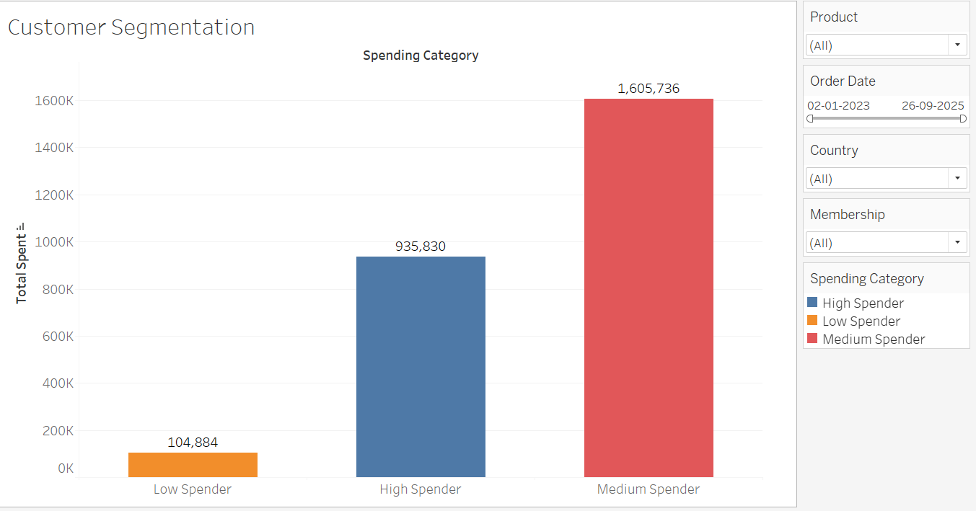

Insights from the above graph:

Based on the graph, it appears that customers who spend a moderate amount (Medium Spenders) tend to spend the most overall, followed by those who spend a lot (High Spenders) and those who spend less (Low Spenders).

**3. Calculated Field for Profit Margin**

Estimate profit margin per order based on a fixed percentage margin on 'UnitPrice'.

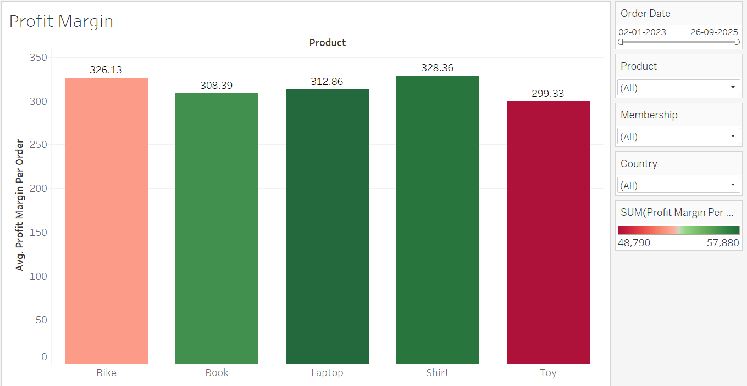

Insights from the above graph:

Based on the graph, it appears that Average Profit Margin Per Order is highest for Shirt, followed by Bike, Laptop, Book and Toy.

**4. Analysis of Membership Types**

Analyze distribution of orders across different membership types.

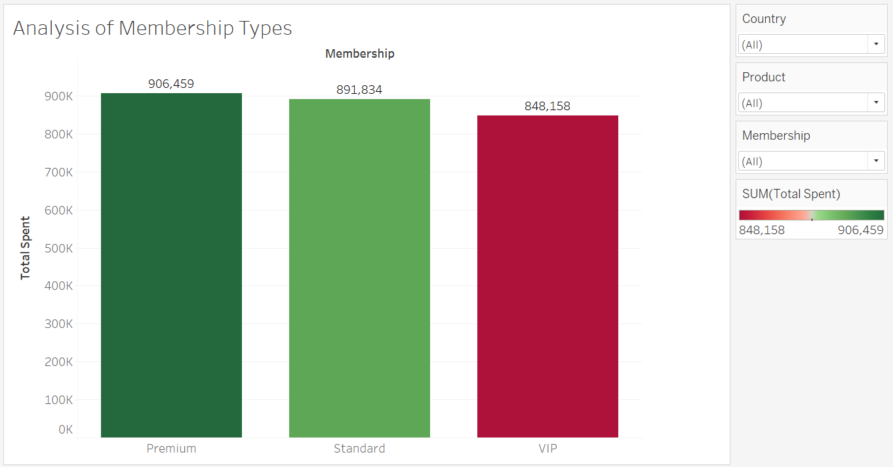

Insights from the above graph:

Based on the graph it appears that, Total Spent by Premium customers is highest, followed by Standard and VIP customers.

**5. Country-Based Analysis**

Compare average order value and total quantity ordered by customers from different countries.

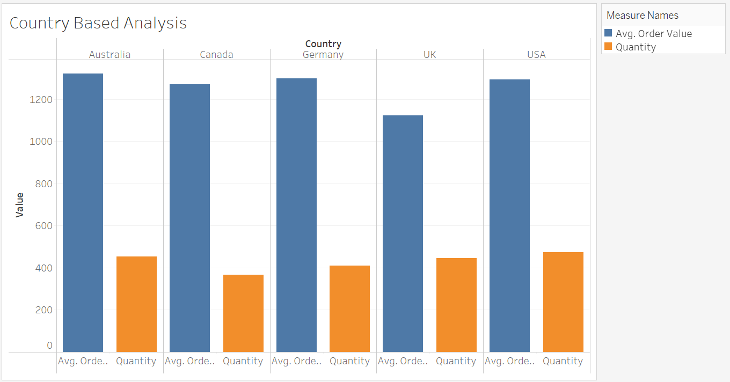

Insights from the above graph:  
  
Based on the graph, it appears that Average Order Value for Australia is highest, followed by Germany, USA, Canada and UK.

Sum of quantity is highest for USA, followed by Australia, UK, Germany and Canada.

**6. Order Frequency Analysis**

Calculate frequency of orders per customer and identify top repeat customers.

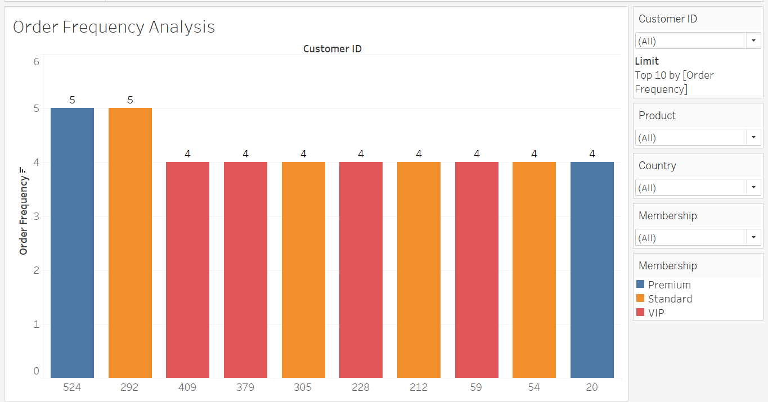

Insights from the above graph:  
  
Based on the above graph, it appears that Top 10 Customer ID with respect to Order Frequency are 524,292,409,379,305,228,212,59,54 and 20.

**7. Product Popularity Analysis**

Identify most and least popular products based on quantity ordered.

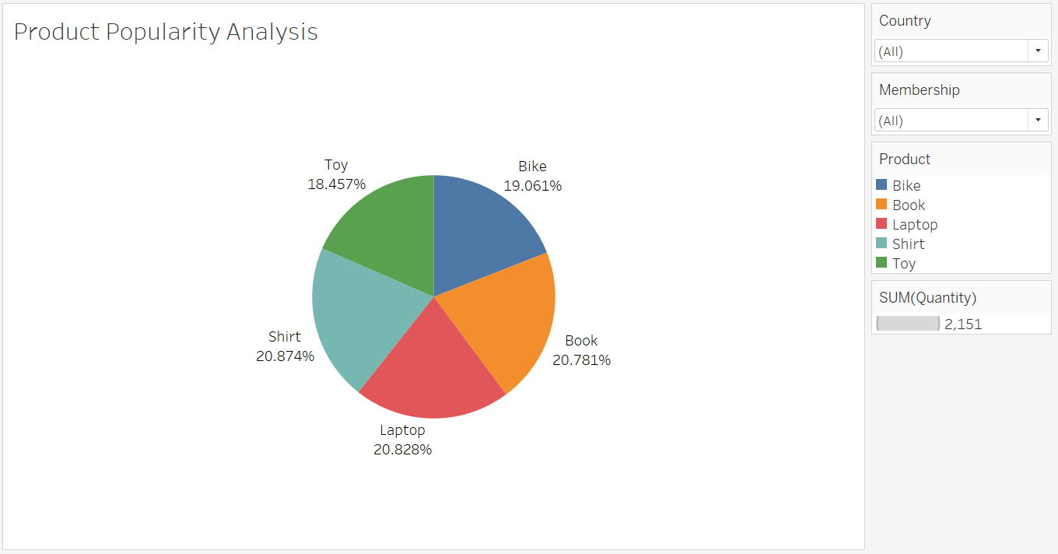

Insights from the above graph:  
  
Based on the above graph, it appears that Shirt is more popular as it’s percentage of Quantity ordered is higher, followed by Book, Laptop, Bike, Toy.

**8. Cohort Analysis**

Analyze spending behavior variation among different customer cohorts.

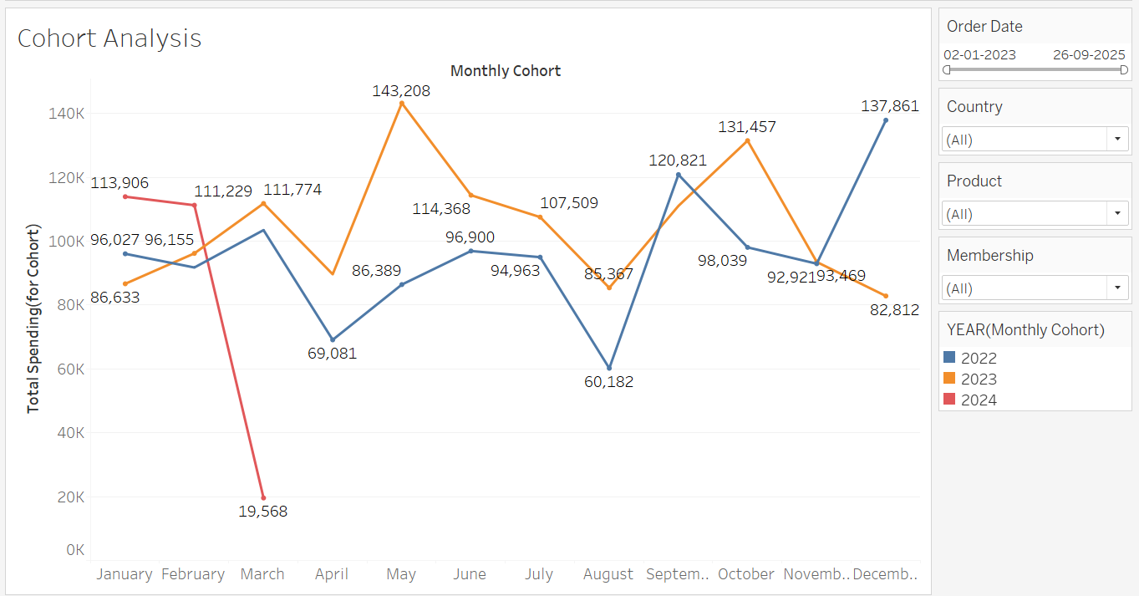

Insights from the above graph:  
  
Based on the graph, it appears that Total Spending by customers peaked in December for the Year 2022, for year 2023 it peaked in May and for year 2024 the it is January till now.

**9. Dynamic Date Filters for Order Analysis**

Implement dynamic date filters to analyze order data over different timeframes.

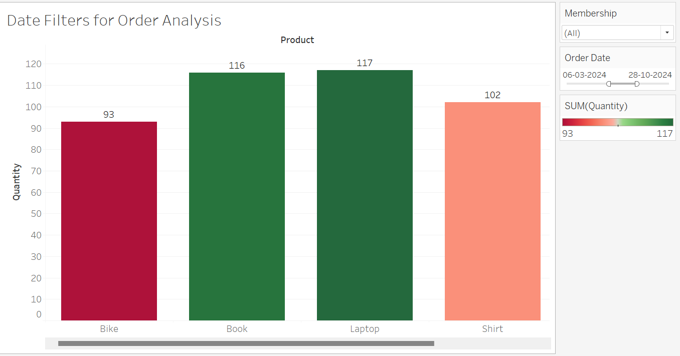

Insights from the above graph:

Based on the above graph, it appears that Quantity ordered for Laptop is highest for the date range 06-03-2024 -28-10-2024, followed by Book, Shirt and Bike.